

Multimodal Insurance Creator
Course Name: Gen AI
Institution Name: Medicaps University – Datagemi Skill Based Course
Student Name(s) & Enrollment No(s)

Sr no | Student Name | Enrollment No
1 | Ananya Madanala | EN22CS301119
2 | Anind Bilthariya | EN22CS301129
3 | Arpita Solanki | EN22CS301202
4 | Ashutosh Singh | EN22CS301221
5 | Avani Sharma | EN22CS301240

Group Name: 08D2
Project No: GAI – 20
Industry Mentor Name: Mr. Rishab Tripathi
University Mentor Name: Dr. Hemlata Patel
Academic Year- 2022 – 26


Problem Statement & Objectives
1.Problem Statement
To build a Multimodal Insurance Creator
2.Project Objectives
- To develop an intelligent multimodal system that can generate both textual and visual outputs for insurance-related topics using Large Language Models (LLMs) and image generation models.
- To integrate a Vector Database for efficient retrieval of relevant insurance knowledge and contextual understanding to support accurate responses.
- To use the Gemini LLM for generating detailed risk explanations, insurance coverage information, and prevention guidelines in a user-friendly format.
- To employ image generation model for creating high-quality infographic visuals based on the user’s input.
3.Scope of the Project
- The project focuses on using AI and multimodal learning to generate both textual and visual insurance explainations.
- It can explain insurance risks, coverage, and prevention through LLM-based analysis.
- It creates infographics using Stable Diffusion XL for better data visualization.
- The system can be extended to different insurance domains like health, auto, and property insurance.
- It demonstrates how LLMs, vector databases, and image generation models can work together for real-world decision support.

Proposed Solution
Key Features
- Text Generation: Explains insurance risks, coverage, and cost using Gemini LLM.
- Image Generation: Creates professional infographics with Stable Diffusion XL.
- Document upload: Uses FAISS for retrieving relevant insurance knowledge.
- Multimodal Report: Merges text and visuals into one comprehensive insurance analysis.
- User Interaction: Accepts user queries and generates instant AI-based insights.

Overall Architecture
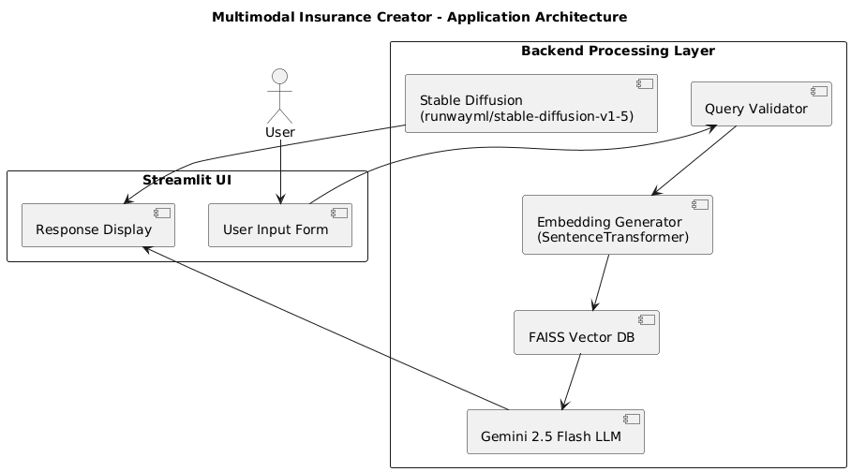
The system follows a layered architecture consisting of four primary layers:

1. Presentation Layer
Component: Streamlit UI
This is the user-facing interface built using Streamlit.
It is responsible for:
- Accepting natural language insurance queries
- Triggering backend processing
- Displaying structured text responses
- Rendering generated infographic images
The UI acts as the entry and exit point of the system.

2. Application Layer
This layer contains the core business logic and processing modules.

a) Query Validator
- Ensures that the user query is related to insurance.
- Prevents irrelevant or malicious inputs.
- Acts as the first filtering mechanism.

b) Embedding Service
- Converts user query into vector embeddings using SentenceTransformer.
- Enables semantic search capability.

c) Retrieval Service
- Interacts with the FAISS Vector Index.
- Retrieves top relevant document chunks from the Insurance PDF knowledge base.
- Provides contextual information to the LLM.

d) LLM Service
- Sends the retrieved context and user query to Gemini 2.5 Flash API.
- Generates structured insurance insights such as:
  - Risk distribution
  - Cost breakdown
  - Coverage analysis
  - Prevention measures
- Also prepares a visual prompt for image generation.

e) Image Generation Service
- Uses runwayml/stable-diffusion-v1-5 model.
- Converts visual prompt into infographic-style image.
- Returns generated image to the UI.

3. Data Layer

FAISS Vector Index
- Stores document embeddings.
- Performs fast similarity search.
- Enables Retrieval-Augmented Generation (RAG).
This layer ensures contextual grounding of LLM responses.

4. External AI Services

a) Gemini 2.5 Flash API
- Provides large language model capabilities.
- Generates structured, context-aware insurance explanations.

b) runwayml/stable-diffusion-v1-5
- Generates visual infographic outputs.
- Enables multimodal capability of the system.

Tools & Technologies Used
- LLM: Google Gemini 2.5 Flash for text generation
- Image Generation: Stable Diffusion XL (SDXL)
- Vector Database: FAISS for similarity search and context retrieval
- Programming Language: Python
- Platform: Streamlit for UI

Results & Output
- Screenshots / outputs
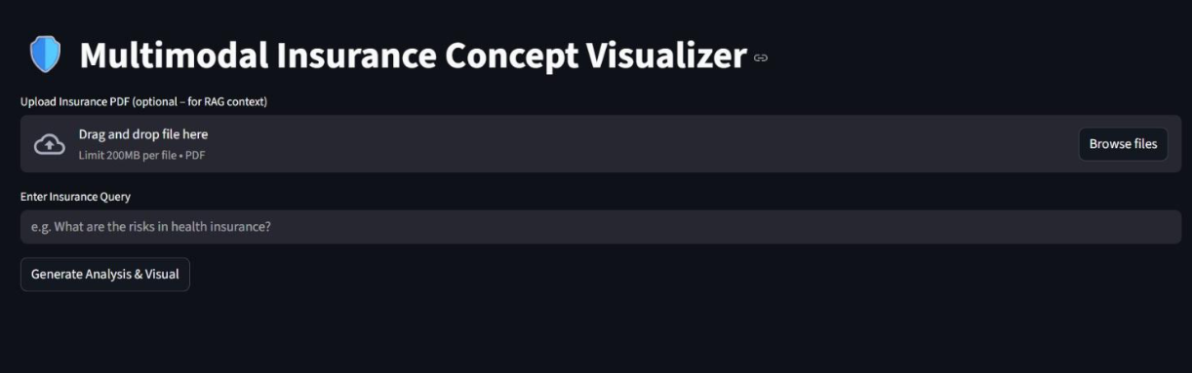

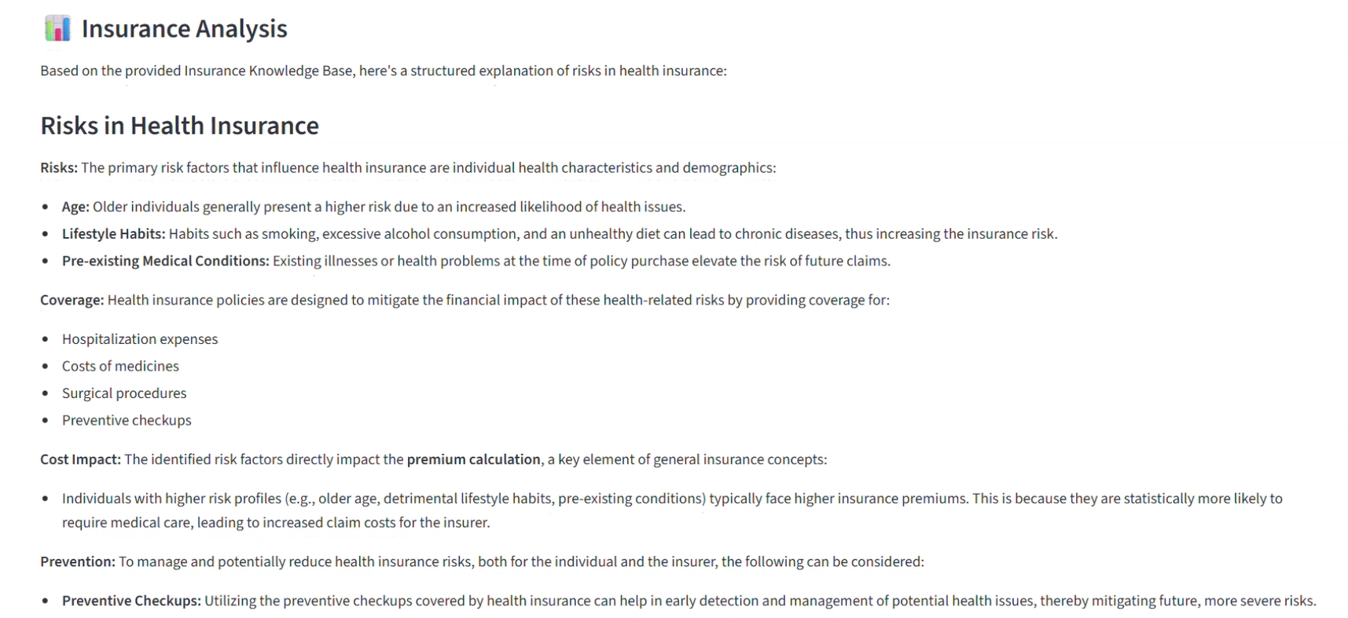
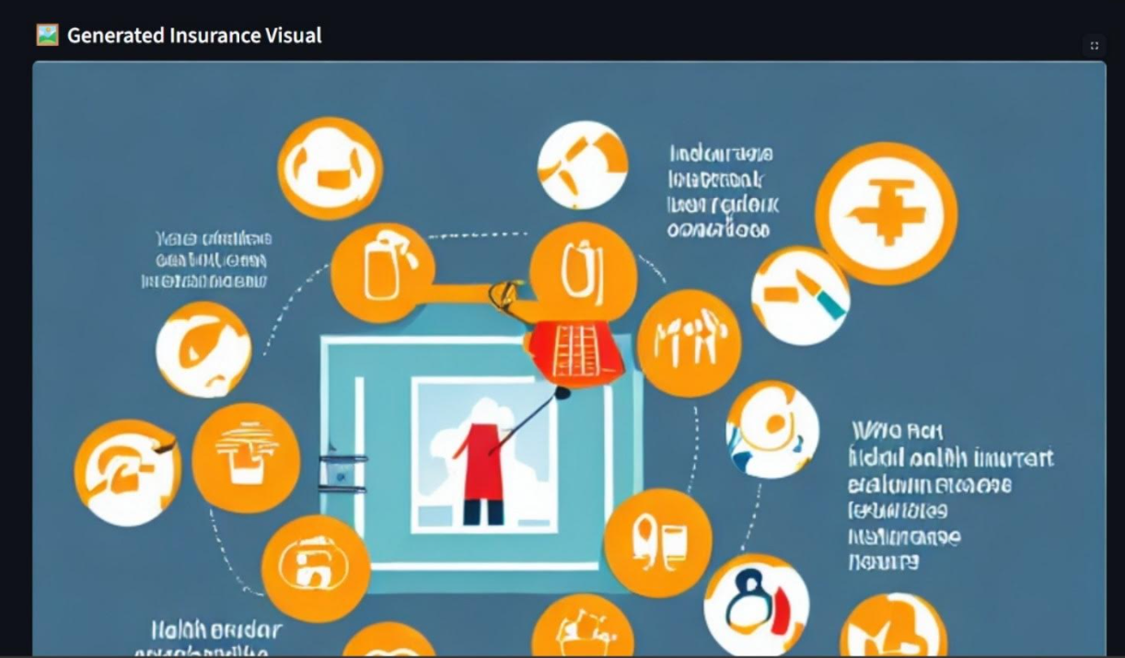

2.Key Outcomes
- Successfully generated text-based insurance analysis using Gemini LLM.
- Created infographic images with Stable Diffusion XL.
- Implemented vector-based knowledge retrieval using FAISS.
- Combined text and visuals into a single multimodal insurance report.
- Demonstrated practical use of AI in the insurance domain for better understanding and presentation.

Conclusion
The project successfully demonstrates how multimodal AI can be used in the insurance domain by combining text generation and image creation. It generates output that include both explanations and visuals, making complex insurance data easier to understand. This integration of Gemini LLM, Stable Diffusion, and FAISS shows the potential of AI in automating insurance risk analysis and communication.
Future Scope & Enhancements
- Integrate real-time insurance data for more accurate risk analysis.
- Add a chatbot interface for interactive policy discussions.
- Include graphical dashboards for premium comparison and claim prediction.
- Deploy the system as a web or mobile application for wider accessibility.
- Fine-tune the LLM and diffusion models for specific insurance domains.

